**GIT ANG GITHUB**

1)Install git

* Google git download and it should lead you to the official website
* Download the installer for Windows (x64)
* A simple download and installation process
* use git -- version to check the version you have

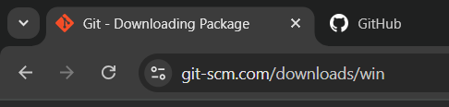

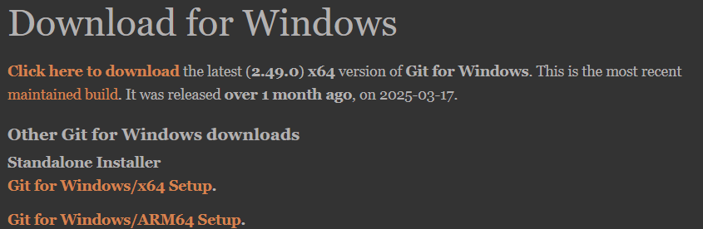

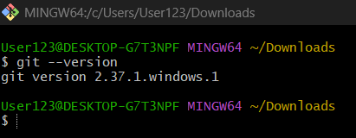

2)Create a repo in github with README.md and .ignore file.

* Go <https://github.com/> and click on the **‘+’** button on top right or the **‘new***’* icon on the left to create a new repository
* Give it a name, make it public or private (preference).
* There are options to create a README file and .ignore file, select them and click create repository

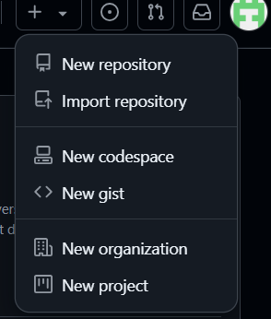

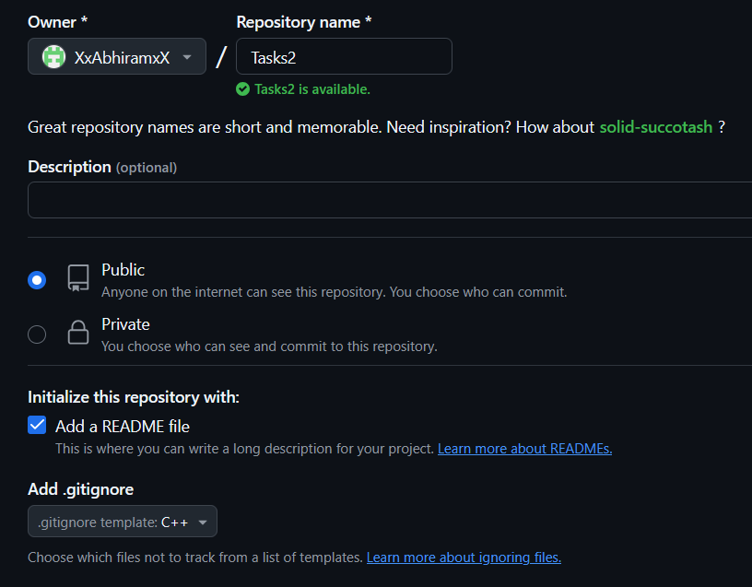

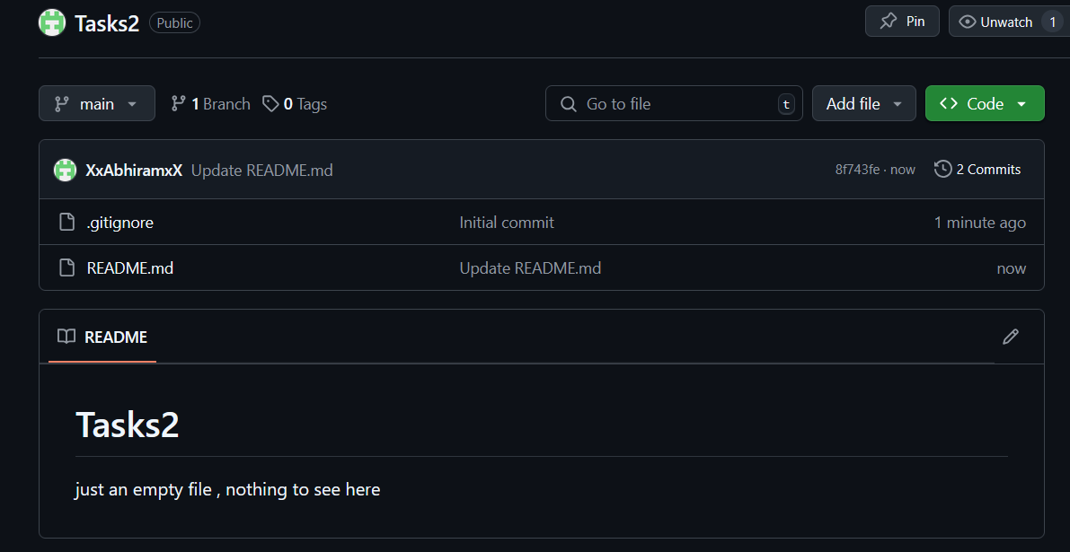

3)Clone the created repo to local.

* copy the repo URL from the the website and in git bash do “**git clone <URL of your github repo>”**
* cd into that folder and use the **‘ls -a’** command to see the hidden files along with the README file

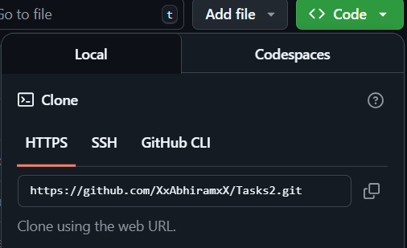

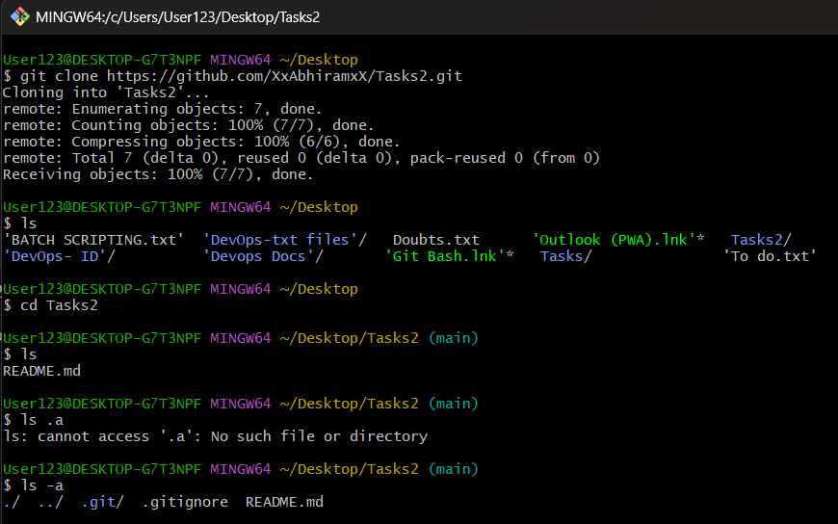

4)Create two files in local repo.

* Just go inside the repo and do **“touch <filename>”**

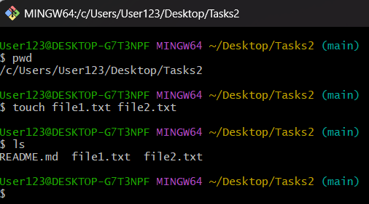

5)Commit two files and push to central Repository.

* **“git add .”** - this command tells git to add everything in the current directory to the staging area
* **“git commit -m <your message>”** - this command takes a snapshot/save of the staged changes and lets you add a message, it creates a commit with id,date,time,messsage,username and email id.

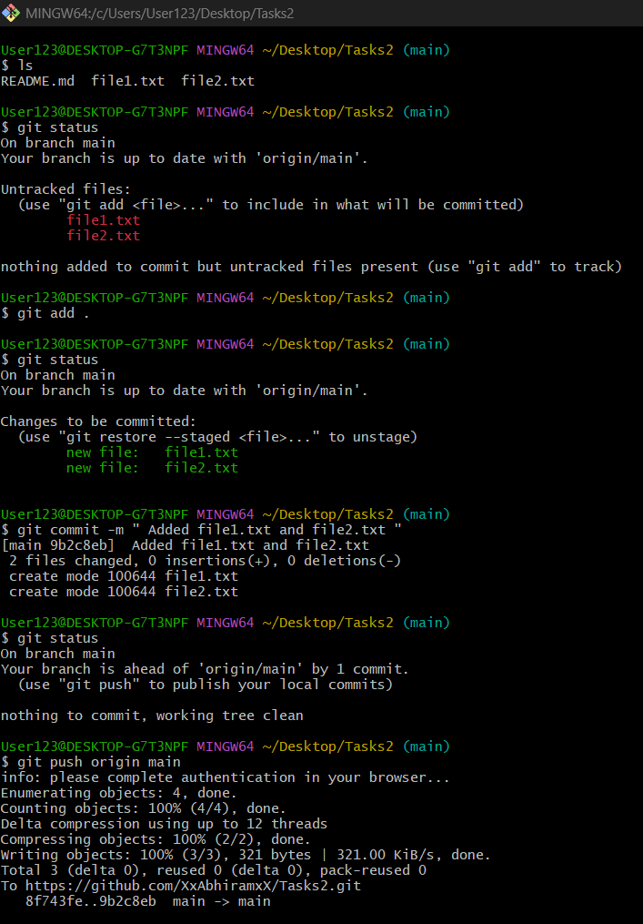

* **“git push origin main”** - tells git to send your local commits to the remote repo, which is github in this case
* **origin** is just the default name for the remote repo. we can change the name if we want to.
* **main** - because thats the branch i am pushing it too, can be replaced with other branch name

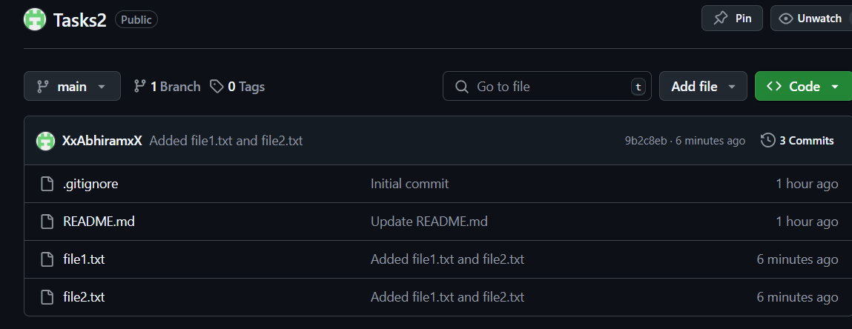

6)Create a branch in local and create a sample file and push to central.

* **git branch <branch_name>** - makes an new branch by the name given
* **git checkout -b <branch_name>** and **git switch -c <branch_name>** both can be used to make a branch and switch to that branch in one line.
* **git branch** to see all the branches
* rest of the steps are same as the above task(5).
* Central refers to the remote repo like github.

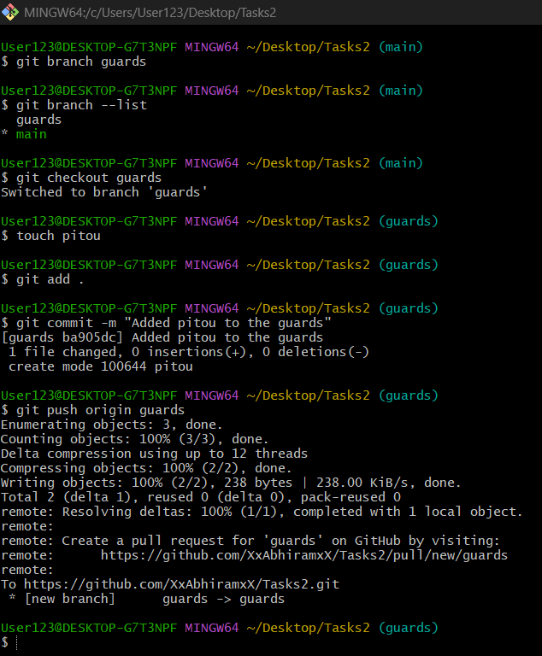

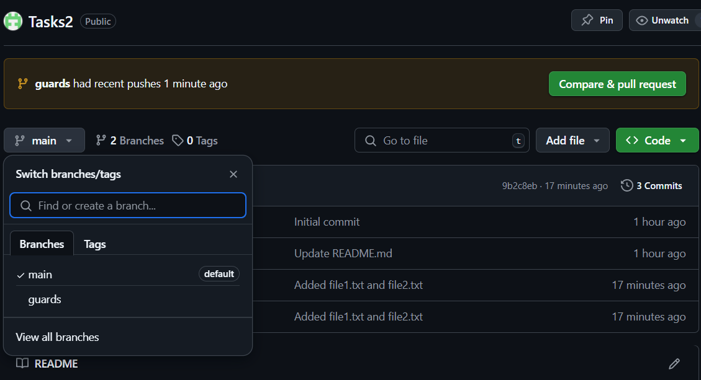

7)Create a branch in github and clone that to local.

* Go to your github and click on the main icon, in there just type the name of your new branch and then click on create branch
* **git fetch** - this downloads all new data(branches, tags, commits) from the remote repository. **Git fetch** is different from **git pull**
* **git branch -r** - to check the remote branches only
* **git clone -b <new_branch>** **<github url> -**

(this step might not be necassary, could also just switch after fetching?)

* **git checkout <new_branch>** - checkout to the new branch
* do **git branch** to see if the branch is present in the local

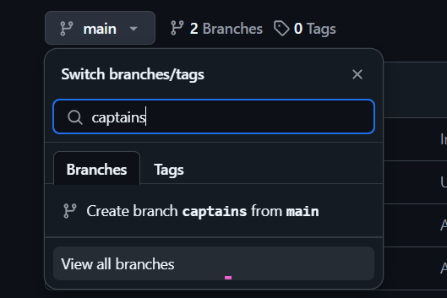

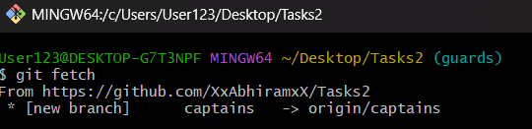

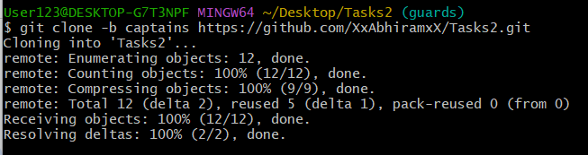

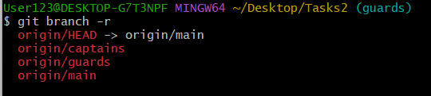

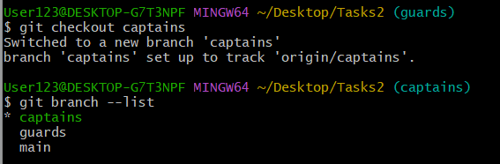

8)Merge the created branch with master in git local.

* Checkout to **main** branch
* then, **git merge <target branch>** to get the new files, codes, changes,commits made on that branch to the branch you are in.

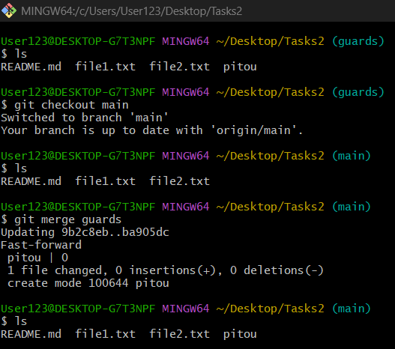

9)Merge the created branch with master in github by sending a pull request.

* make some changes to a branch and push it to main branch in remote repo using **git push origin <branch_name>**
* Go to github and you should see a **‘compare and pull request**’ option pop up, click on it.
* Make sure the base branch is **main**, add a title if you want and click on **create pull request** and then **merge pull request.**

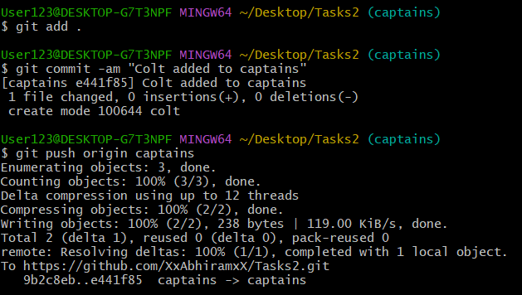



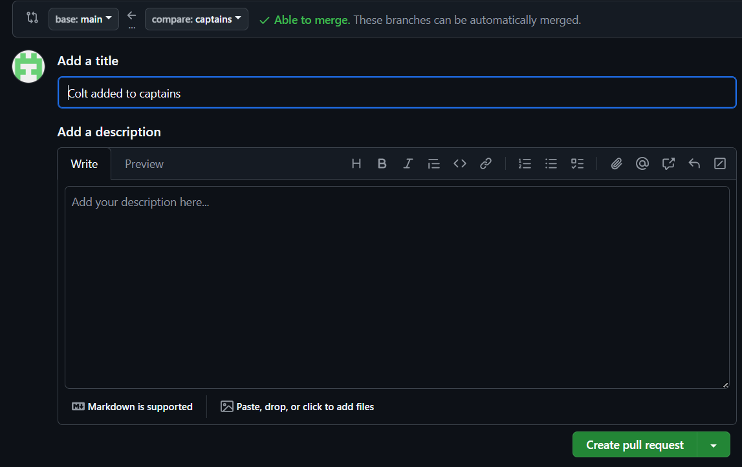

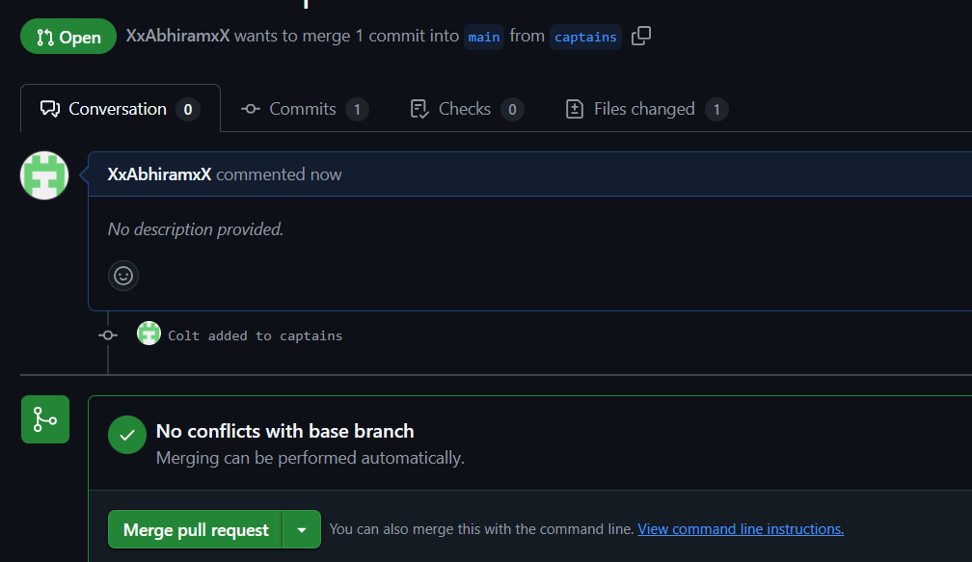

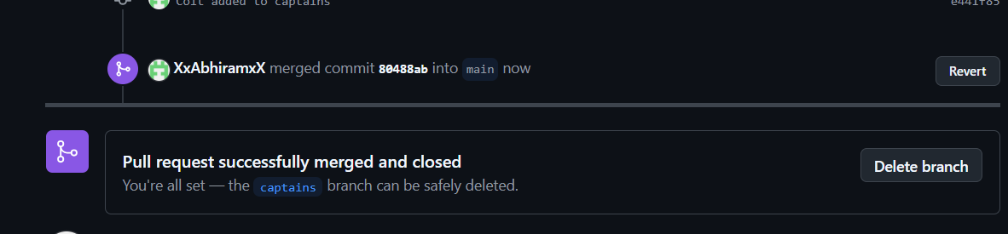

10)create a file in local and send that to branch in github.

* Create a new file in the branch and commit it. Then,
* **git push origin<current_branch>** - this sends the changes to the github repo

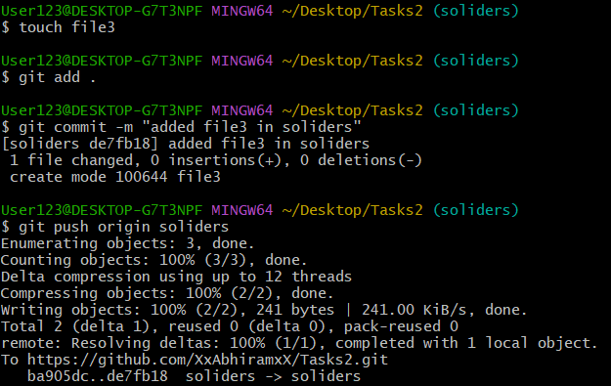



11)clone only a branch from github to local.

* First create a new branch in your remote repo
* go to your local repo and do **git fetch origin**
* then do **git checkout -b <branch_name> origin/<remote_branch_name>** - this creates a local branch from origin/remotebranch and switches you to that branch
* This wont clone the entire repo again, no new folders and wont cause a nested repo
* **git clone --branch <branch_name> --single-branch <github url>** - causes a nested repo

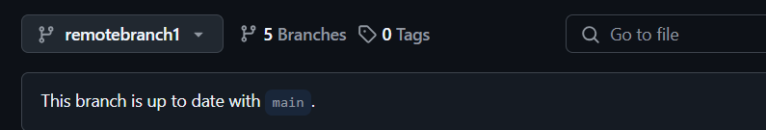

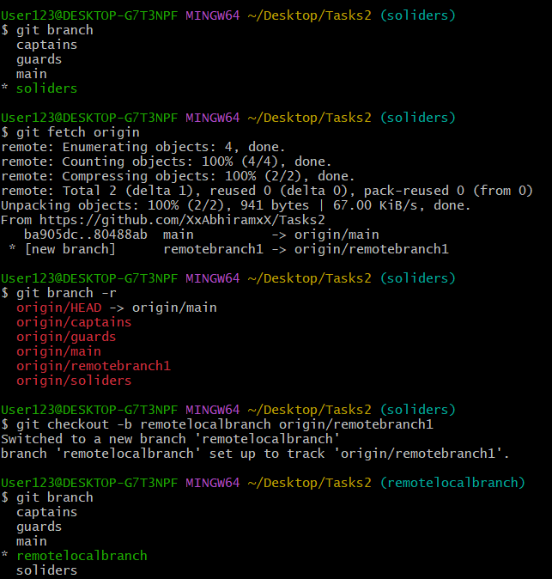

12)create a file with all passwords and make that untrackable with git.

* Create a file with your passwords but dont commit it or add it.
* open the .**gitignore** file and add the passwords file to it.
* now commit only the **.gitignore** file and push it.
* had to use **git push origin remotelocalbranch:remotebranch1** because the local branch was not automatically tracking the remote one.
* using regular **git push origin <branch_name>** would not update the remote branch in this case and create a new branch on github.

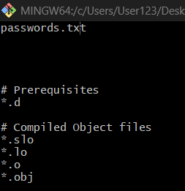

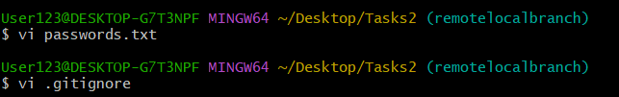

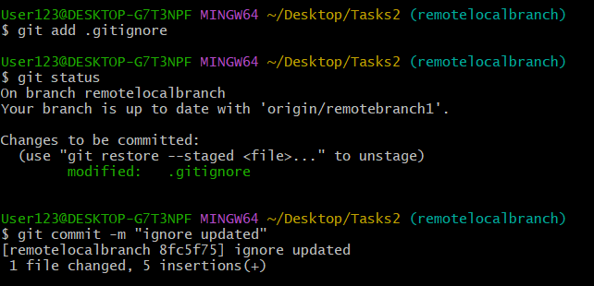

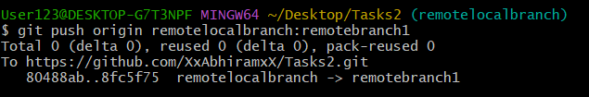

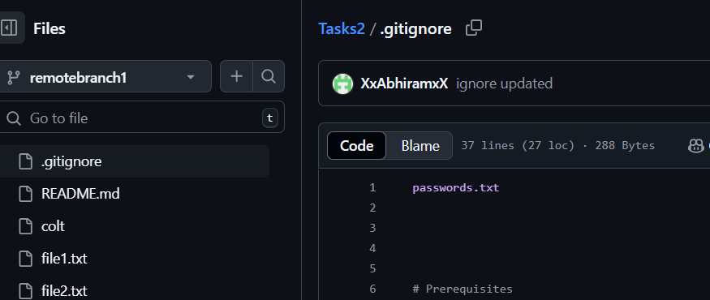

13)make a commit and make that commit reset without savings changes.

* **git add .** and **git commit -m " "** to make changes and add a new commit.
* Reset the commit and discard the changes just made using **-**
* **git reset --hard HEAD~1** - this undos the last commit completely
* **git reset** - Move the HEAD and current branch pointer to a different commit
* **hard** - reset the working directory and staging area (dangerous)
* **HEAD~1** - Means "1 commit before HEAD" — the previous commit

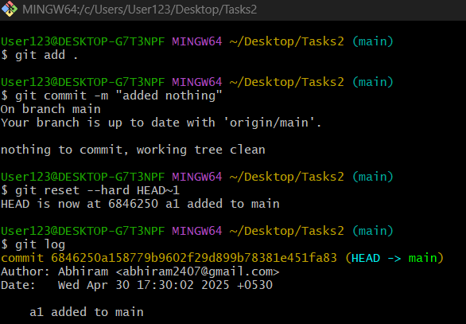

14)Revert a commited commit to the older version.

* **Git log** to get the commit history and details including ID
* copy the commit id of the one you want to undo/revert
* **git revert <commit ID>** - git creates a new commit that reverses the changes made in that commit id’s detail
* the code goes back to the previous version, but no history is deleted.

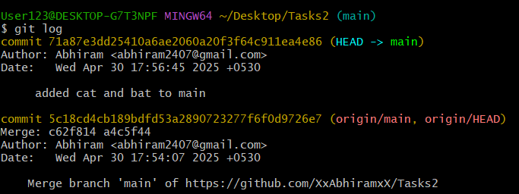

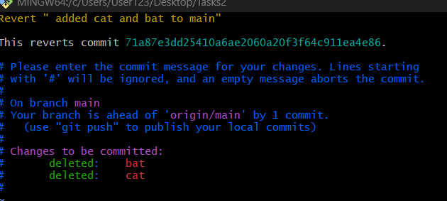

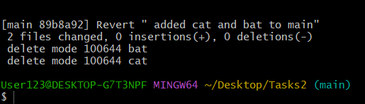

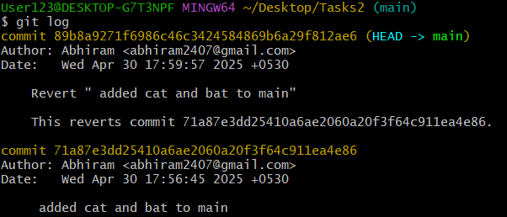

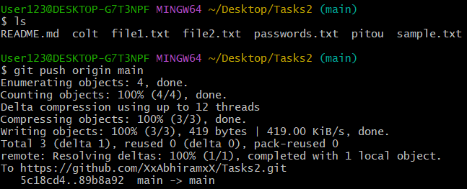

15)push a file to stash without savings the changes and work on another file.

**Git stash** temporarily saves your uncommitted changes, so you can switch branches or do other tasks without committing them.

* create 2 files in the branch but dont add or commit yet.
* use **git stash push <file1>** , to stash it away and work on the second file .
* after the work is done on file 2 , add and commit it .

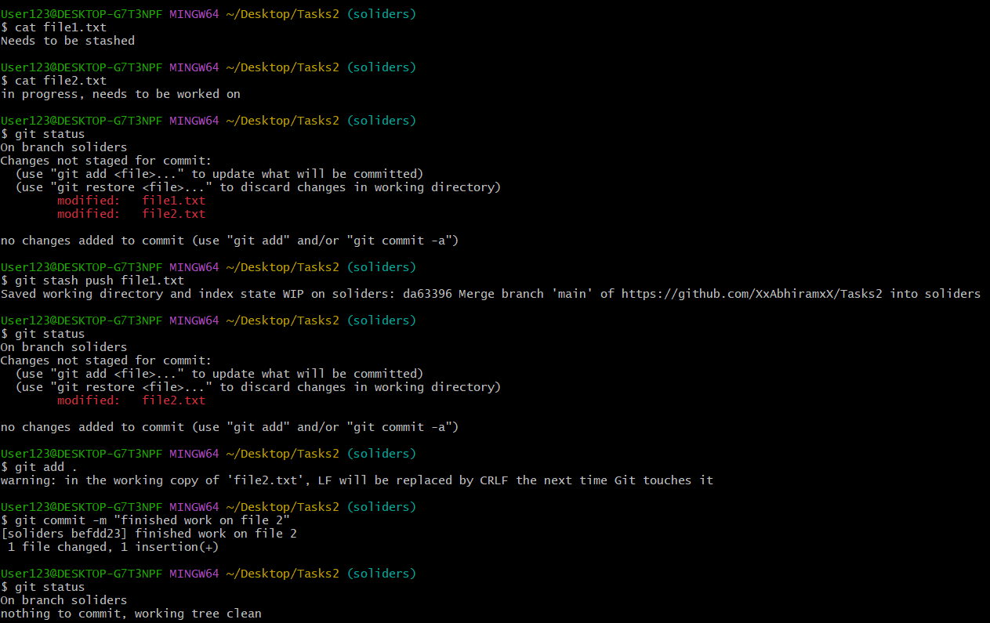

16)undo the stash file and start working on that again

* **git stash list** - to confirm that the file is safe and in the stash list
* **git stash pop** - Bring backs the most recent stashed changes and removes them from the stash list
* now we can work on the file and add and commit it.

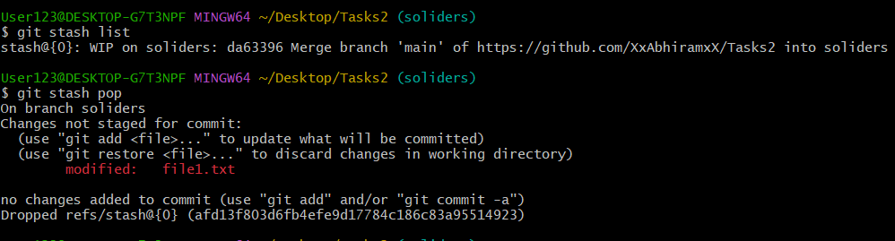

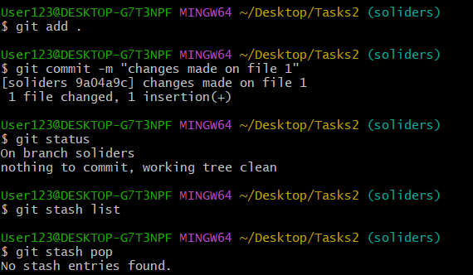.

17)generate a ssh-keygen and configure into github.

* create a public key pair using **ssh-keygen** on the local system
* got to its location **(~/.ssh)** and copy the public key **(id_rsa)**
* Go to your **GitHub profile** and select **SSH and GPG keys** and click on **new ssh key**
* Paste your public key in there and select Authentication Key as the type and click **SSH key**
* To test the connection do **ssh -T git@github.com** followed by yes.

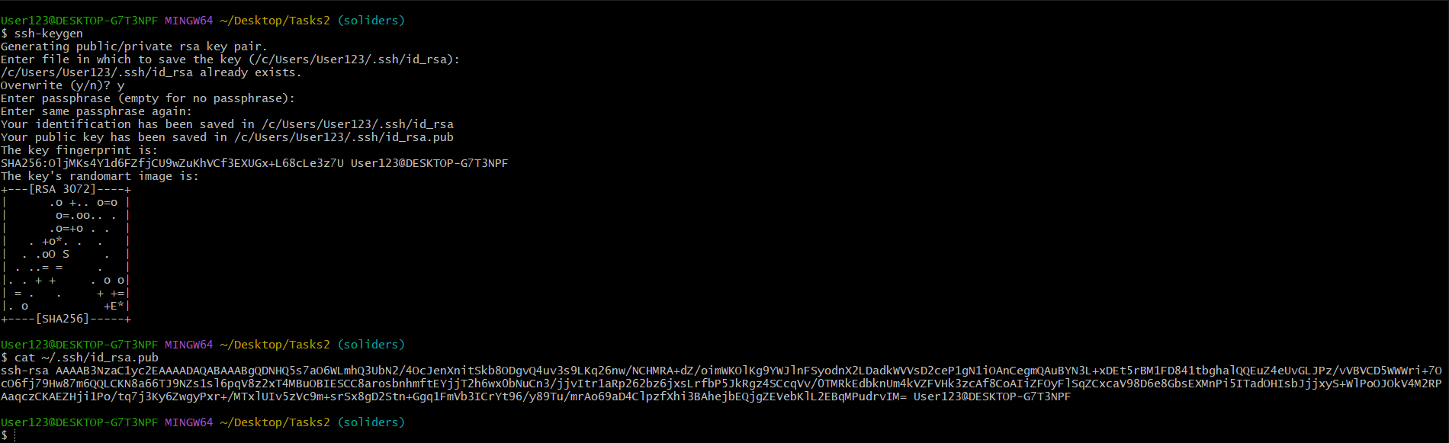

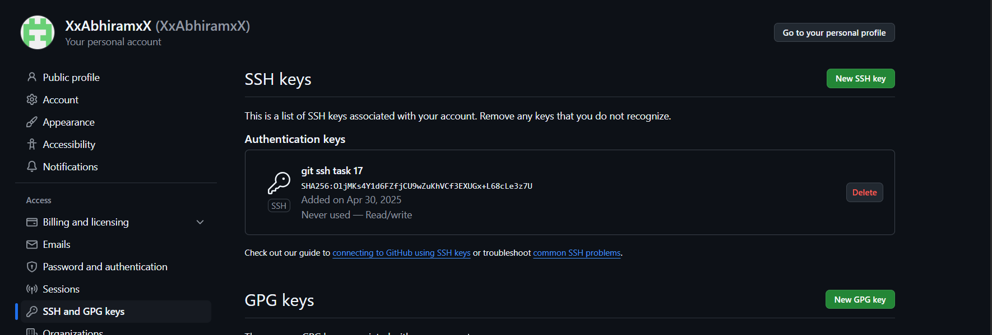

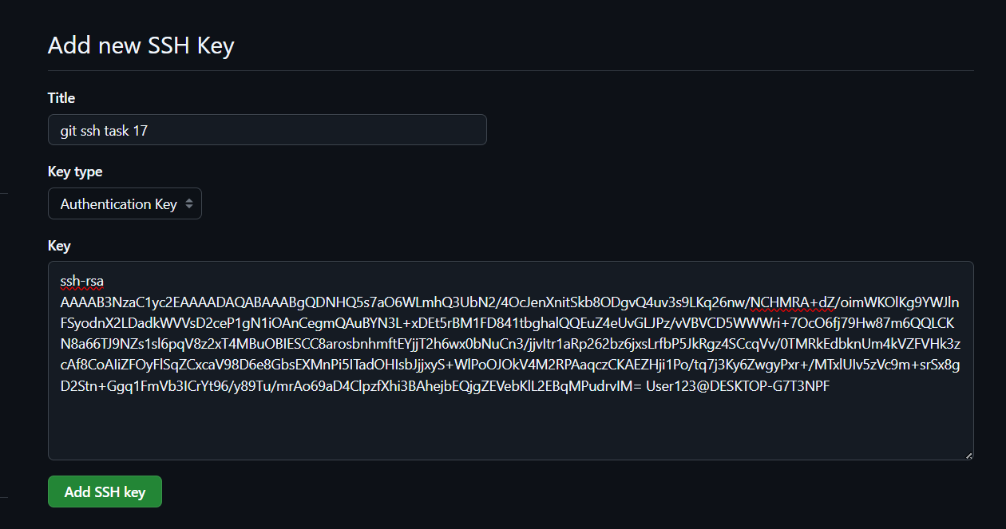

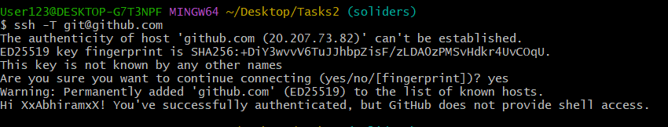

18)configure webhooks to github.

* A webhook in GitHub lets you notify an external server or service whenever certain events happen in your repository — like a push, pull request, or release.
* Go to your repository’s settings and click on webhooks on the left tab
* Click on add webhooks

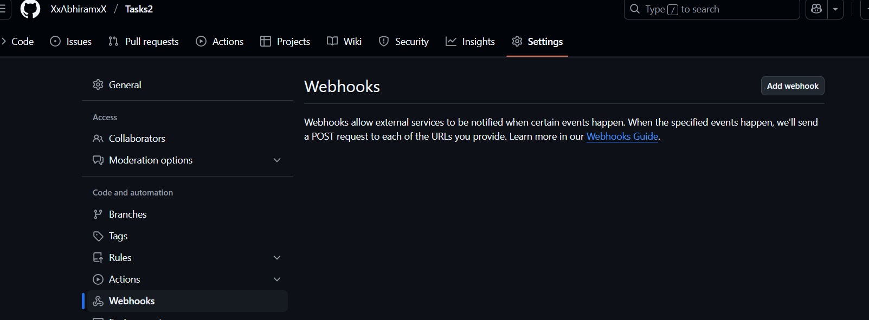

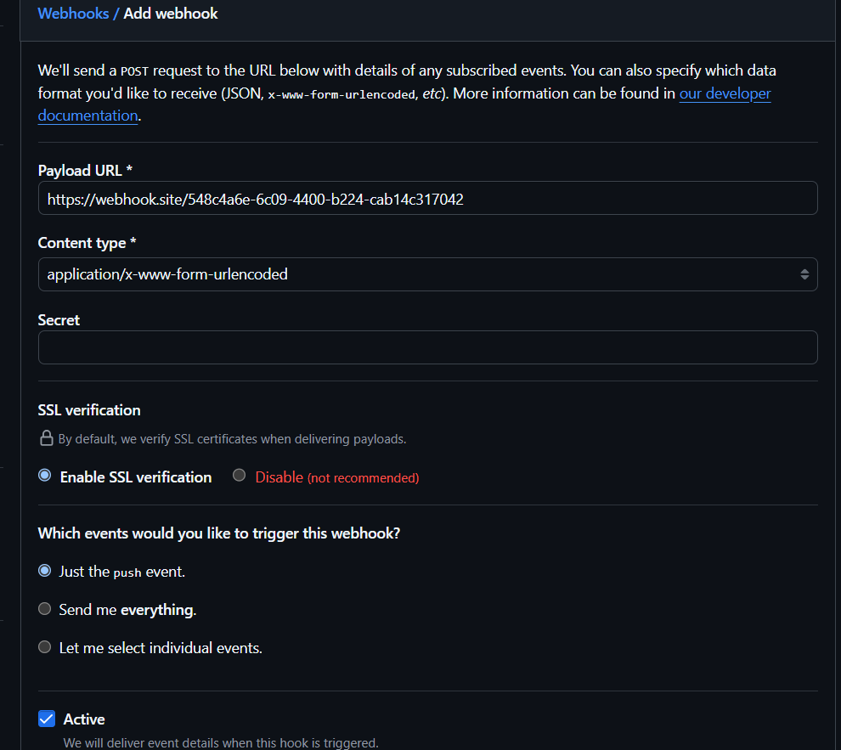

19) basic understanding of .git file.

source - https://git-scm.com/book/en/v2/Git-Internals-Plumbing-and-Porcelain

* *.git* is a hidden folder that Git creates inside your repository when we run **git init** or also when we run **git clone <repo-url>.**
* The *.git* folder is a hidden directory within a Git repository that stores all the metadata necessary for version control, including the commit history, branch information, and configuration settings. It essentially functions as a database for your project's changes, allowing you to track, manage, and revert changes.

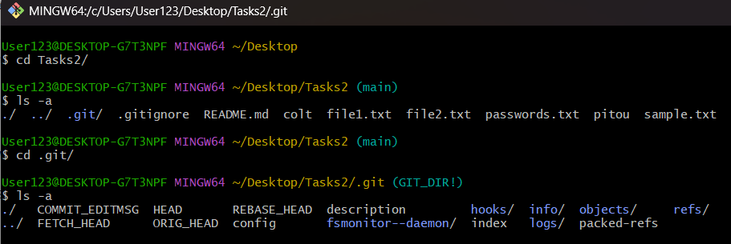

* If you want to back up or clone your repository, copying this single directory elsewhere gives you nearly everything you need.
* The description file is used only by the GitWeb program.
* The config file contains your project-specific configuration options, and the info directory keeps a global exclude file for ignored patterns that you don’t want to track in a .gitignore file.
* The *hooks* directory contains your client- or server-side hook scripts. Contains sample scripts that run automatically when certain Git actions happen (like commit, push, etc.)
* The *objects* directory stores all the content for your database,Stores everything Git tracks like commits, files, folders (trees), tags, etc.
* The *refs* directory holds pointers to commit objects, including branch heads and tags, which are used to track the history of the project. Contains references (pointers) to commits. Eg:- heads/ → branches (like main, dev) or tags/ → tags (like v1.0, release-1)
* the HEAD file points to the branch you currently have checked out, and the index file is where Git stores your staging area information.

20)Check all the logs of git.

* **Git log**

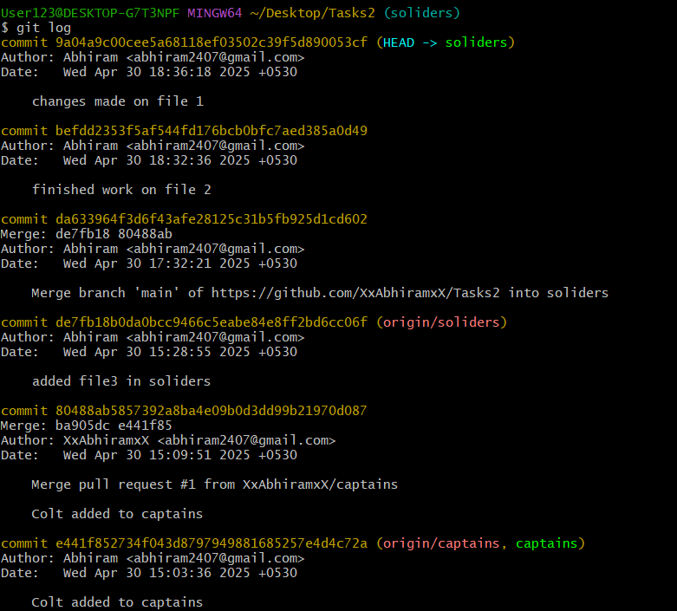

21)Rename the commit message.

* **git commit --amend** - Git will open the last commit message in your text editor
* Change the message, save and close the editor.
* **git commit --amend -m "new commit message"** - to directly change it

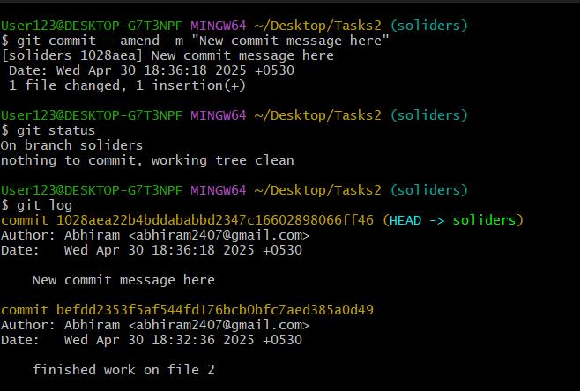

22)Merge multiple commits into single commit.

* **git rebase -i HEAD~3** - to squash the last 3 commits
* **HEAD~3** to go back 3 commits from the current commit
* change the 2nd and 3rd pick to squash



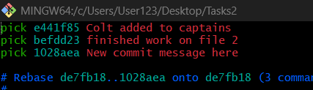

* **pick** keeps that commit message
* **squash** merges this commit into the one above it
* Edit the message, save and quit.
* **Git log** again to see the change

